
ATAR HUMAN BIOLOGY – UNIT 1
TASK 4 –DIGESTIVE AND EXCRETORY SYSTEMS TEST

NAME: _________________________________ WEIGHTING: 5 %
DUE DATE: _________________________________ MARK: ______ / = ______ %

Important Information for Students
- There are THREE sections in this test - Multiple Choice, Short Answer and Extended Answer.
- This is a closed-book assessment (no notes are allowed)
- The time allowed to complete the test is 60 minutes.
- Write your answers to the Multiple Choice section on the separate answer sheet provided.
- Write your answers to the Short Answer section in space provided.
- Write your answers to the Extended Answer section in space provided.

Sections | Marks Allocation | Your Total
A - Multiple Choice | 10
B - Short Answer | 32
C - Extended Answer | 10
TOTAL | 52

ATAR HUMAN BIOLOGY UNIT 1

Multiple Choice Answer Sheet

Name: _____________________________

Answer all questions by circling the letter corresponding with the most correct answer.

1. A B C D

2. A B C D

3. A B C D

4. A B C D

5. A B C D
6. A B C D

7. A B C D

8. A B C D

9. A B C D

10. A B C D

SECTION A - Multiple Choice Questions (10 Questions – 10 Marks)

Answer all questions on the separate Multiple Choice Answer Sheet.

- Substances absorbed into the lacteals are transported to the:
- circulatory system.
- liver.
- lymph system.
- lungs.

- Emulsification of fat:
- is a form of mechanical digestion.
- is brought about by pancreatic lipase.
- requires an acidic environment.
- changes fat to a form that can be absorbed.

- The functions of the large intestine are to:
- digest carbohydrates and absorb water.
- absorb all nutrients vital to the body.
- produce enzymes to break down fibre.
- manufacture vitamins and absorb water.

- Which of the following describes the direction of blood flow through the kidney?
- renal artery, renal vein, afferent arteriole, efferent arteriole, peritubular capillaries.
- renal vein, renal artery, afferent arteriole, efferent arteriole, peritubular capillaries.
- renal artery, efferent arteriole, afferent arteriole, peritubular capillaries, renal vein.
- renal artery, afferent arteriole, efferent arteriole, peritubular capillaries, renal vein.

- Though the alimentary canal has food materials move through it, it can also be classed as an excretory organ because:
- is excretes faeces.
- it excretes unused substances from the body such as fibre.
- it excretes waste products produced by the liver.
- it changes the food that enters our mouth and excretes what we cannot digest.

- What is the role of the kidney in the excretory system of mammals?
- To remove salt from the body and to keep water in the body.
- To remove water from the body and keep salt in the body.
- To remove nitrogenous waste from the body and maintain water levels in the body.
- To remove water from the body and maintain levels of nitrogenous substances in the
body.

- Normally, concentrations of substances that are metabolically important to the body are:
- High in the glomerular filtrate but are only found in trace amounts in the urine.
- Low in the glomerular filtrate but high in the urine.
- High in both the glomerular filtrate and the urine.
- Low in both the glomerular filtrate and the urine.

- What part does the stomach play in protecting us from pathogenic bacteria?
- Its digestive enzymes attack any bacteria which may enter.
- The high temperature in the stomach denatures the enzymes which pathogenic bacteria contain.
- The mucus produced by the gastric pits in the stomach traps bacteria.
- The low pH of the stomach generally kills most bacteria.

The table below shows the normal % composition of some components of blood plasma, fluid in the Bowman’s capsule and urine.

Component | Blood plasma | Bowman’s capsule | Urine
Urea | 0.03 | 0.03 | 2.00
Uric acid | 0.004 | 0.004 | 0.05
Glucose | 0.10 | 0.10 | None
Amino acids | 0.05 | 0.05 | None
Minerals | 0.72 | 0.72 | 1.50
Proteins | 8.00 | none | none

- Why is there a large amount of protein found in the blood but none in the capsule or urine?

- The proteins are converted to amino acids before they enter the capsule.
- The proteins are too large to move through the capsule membrane.
- The proteins are needed by the body and so are not filtered.
- The proteins are converted by the capsule into amino acids.

10. Which of the following is NOT a function of saliva?
- Initial digestion of proteins.
- Lubrication of the mouth.
- Initial digestion of carbohydrates.
- Lubrication of food.

SECTION B – Short Answer Questions ( 9 Questions – 32 Marks)

- Label the indicated parts on the diagram of the alimentary canal shown. (3 marks)
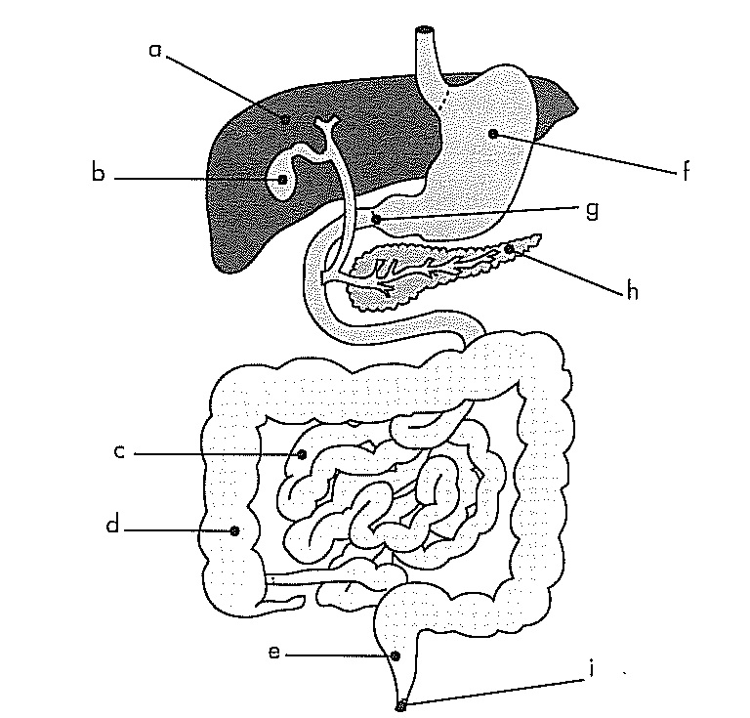

a: ___________________________

b: ___________________________

e: ___________________________

f: ___________________________

g: ___________________________

h: ___________________________

- Explain why mechanical digestion is a vital part of the digestion process? (2 marks)
______________________________________________________________________________________________________________________________________________________________________________________________________________________________
__________________________________________________________________________

- State one complication that could occur if “g” did not work properly? (1 mark)
____________________________________________________________________________________________________________________________________________________
__________________________________________________________________________

- Discuss using examples, how diet can affect the functioning of the digestive system.
(3 marks)
____________________________________________________________________________________________________________________________________________________________________________________________________________________________________________________________________________________________________________________________________________________________________________________________________________________________________________________________
- Complete the table below, summarising chemical digestion in the alimentary canal.
(5 marks)

Dietary Nutrient | Enzyme | Nutrient to be absorbed | What part/s of the alimentary canal does this chemical digestion occur in?
Protein
 | Lipase

- Discuss how fatty acids are absorbed and enter the blood stream from the small intestine; include structures of the small intestine and how they maximise the process of absorption, and the processes involved. (6 marks)
____________________________________________________________________________________________________________________________________________________
____________________________________________________________________________________________________________________________________________________
__________________________________________________________________________________________________________________________________________________________________________________________________________________________________________________________________________________________________________________________________________________________________________________________________________________________________________________________________________________________________________________________________________________________________________________________________________________________________________________________________________________________________________________________________________________________________________________________________________________________________________________________________________________________________________________________________________________________________________________________________
- Refer to the diagram below of the kidney nephron and associated blood vessels.
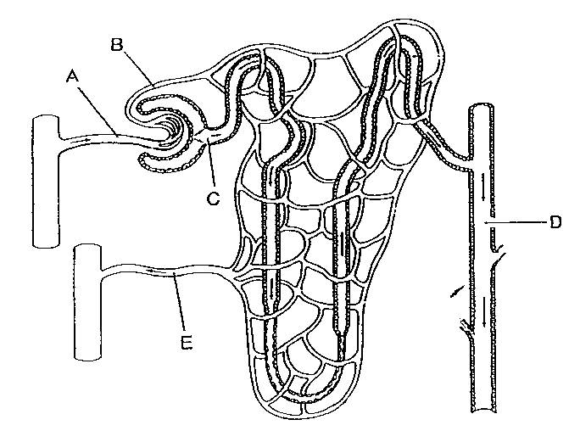

Outline three reasons why the nephron is suited to its function. (3 marks)
____________________________________________________________________________________________________________________________________________________
______________________________________________________________________________________________________________________________________________________________________________________________________________________________
____________________________________________________________________________________________________________________________________________________

- Urea is a toxic waste product that is produced by normal processes in the human body. Explain how urea comes to be present in the body (3 marks)
____________________________________________________________________________________________________________________________________________________
____________________________________________________________________________________________________________________________________________________
____________________________________________________________________________________________________________________________________________________

9. At any given time, the liver contains 10% of the total blood in the body and it filters around 1.4L/min.
Discuss the role of the liver in both the digestive and excretory systems and how these systems are linked together. (6 marks)

____________________________________________________________________________________________________________________________________________________
____________________________________________________________________________________________________________________________________________________
____________________________________________________________________________________________________________________________________________________
________________________________________________________________________________________________________________________________________________________________________________________________________________________________________________________________________________________________________________________________________________________________________________________________________________________________________________________________________________________________________________________________________________________________________________________________________________
________________________________________________________________________________________________________________________________________________________________________________________________________________________________________________________________________________________________________
________________________________________________________________________________________________________________________________________________________________________________________________________________________________________________________________________________________________________

SECTION C – Extended Answer Question (1 Question – 10 Marks)
Your response to this question can be written in paragraph form, tables or can refer to labelled diagrams in support.

The nephron is the primary structure concerned with the formation of urine. It is composed of a number of parts, including the:
  - Glomerulus
  - Proximal convoluted tubule
  - Distal convoluted tubule
  - Collecting duct
Discuss the role played by each of these nephron parts in the formation of urine. Include the processes and chemicals involved, and how the structure suits its function. (10 marks)

____________________________________________________________________________________________________________________________________________________
____________________________________________________________________________________________________________________________________________________
____________________________________________________________________________________________________________________________________________________
____________________________________________________________________________________________________________________________________________________________________________________________________________________________________________________________________________________________________________________________________________________________________________________________________________________________________________________________________________________________________________________________________________________________________________________________________________________________________________________________________________________________________________________________________________________________________
____________________________________________________________________________________________________________________________________________________
____________________________________________________________________________________________________________________________________________________
____________________________________________________________________________________________________________________________________________________________________________________________________________________________________________________________________________________________________________________________________________________________________________________________________________________________________________________________________________________________________________________________________________________________________________________________________________________________________________________________________________________________________________________________________________________________________________________________________________________________________________________________________________________________________________________________________________________________________________________________________________________________________________________________________________________________________________________________________________________________________________________________________________________________________________________________________________________________________________________________________________________________________________________
__________________________________________________________________________________________________________________________________________________________________________________________________________________________________________________________________________________________________________________________________________________________________________________________________________________________________________________________________________________________________________________________________________________________________________________________________________________________________________________________________________________________________________________________________________________________________________________________________________________________________________________________________________________________________________________________________________________________________________________________________
__________________________________________________________________________________________________________________________________________________________________________________________________________________________________________________________________________________________________________________________________________________________________________________________________________________________________________________________________________________________________________________________________________________________________________________________________________________________________________________________________________________________

